Australian National Botanic Gardens
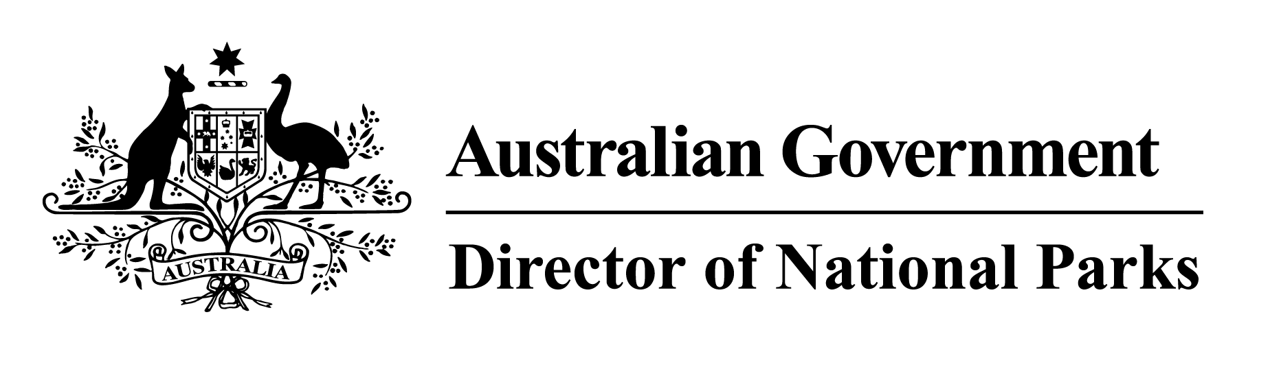

Application form for release of plant material from the
Australian National Botanic Gardens

This form should be used if you want plant material from ANBG. (If you want to conduct research within the grounds of ANBG you will require a permit.) You will also be required to sign an 'Agreement for the Supply of Biological Materials'.

PART A – Details of applicant and proposed permit holder(s)
A1. Applicants name(s)
Include the name of each individual or group (company, partnership or association) to whom the material will be supplied. In the case of a company, partnership or association, include:
full names of all directors, partners or committee members;
Australian Business Number;
any business or trading name used in the conduct of the activity for which a permit is sought;
whether any such business or trading name is registered;
if so, the State/Territory of registration and registration numbers.
In the case of an individual(s), include the full name of each person to whom the material will be supplied.

A2. Contact details
Include business address, postal address, telephone, fax and email of each proposed applicant.

A3. Relevant qualifications and experience of applicant(s)
If an applicant is an individual state their relevant qualifications and experience to carry out the activities.
If an applicant is a group (company, partnership or association), state the name and relevant qualifications and experience of all officers or employees of the group who will carry out the activities. (attach further pages if necessary)

PART B – Description of the research and plant material required
B1. List the types and quantities of plant material required (attach a schedule if necessary)
Please check the spelling of plant names using APNI (http://www.anbg.gov.au/cgi-bin/apni) before submitting this application

B2. Describe the purpose for which the plant material is required

B3. Previous applications
Have you previously obtained plant material from the Australian National Botanic Gardens? If so, please write the reference number from that permit and the date of expiry.

B4. Outline why is it proposed to obtain this material from the Australian National Botanic Gardens rather than at other locations.

B5. List the reports and/or publications that are expected to follow from this research.

Declaration

Please complete the application form, then read carefully and sign the following declaration.

I, ________________________________________________ (full name), declare that the information
contained in this application is correct to the best of my knowledge.

Signature ________________________________________________

Date ______/________/____________

Attachments

Please tick to indicate that you have included the following material with your application
 Agreement for the supply of Biological material
An estimate of costs for the supply of the material will be sent to you after receipt of this application.

Please send this application to:
The Director
Australian National Botanic Gardens
GPO Box 1777
Canberra ACT 2601
AUSTRALIA

